**DIGITAL SIGNAL PROCESSING LAB EXPT.11**

**NIKHIL ROUT**

**22BEC1020**

**AIM:**

**➢ Design of various FIR filter using windowing method.**

**LOW PASS FIR FILTER:**

%low pass

order = 48;

cutoff_frequency = 0.5;

figure(1);

b = fir1(order, cutoff_frequency, 'low', hamming(order+1));

freqz(b, 1, 512);

figure(2);

b = fir1(order, cutoff_frequency, 'low', hanning(order+1));

freqz(b, 1, 512);

figure(3);

b = fir1(order, cutoff_frequency, 'low', rectwin(order+1));

freqz(b, 1, 512);

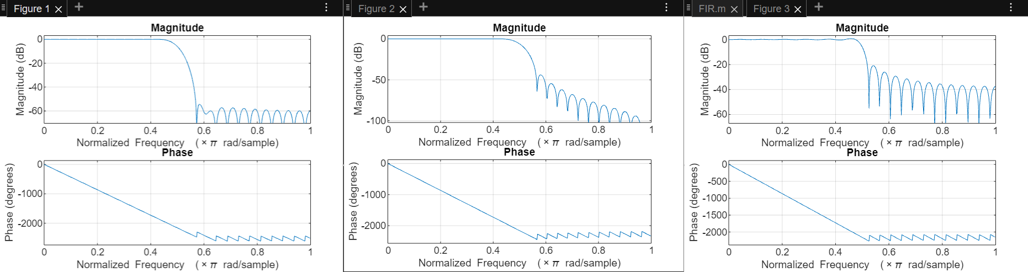

**HIGH PASS FILTER:**

% high pass

order = 48;

cutoff_frequency = 0.4;

figure(1);

b = fir1(order, cutoff_frequency, 'high', hamming(order+1));

freqz(b, 1, 512);

figure(2);

b = fir1(order, cutoff_frequency, 'high', hanning(order+1));

freqz(b, 1, 512);

figure(3);

b = fir1(order, cutoff_frequency, 'high', rectwin(order+1));

freqz(b, 1, 512);

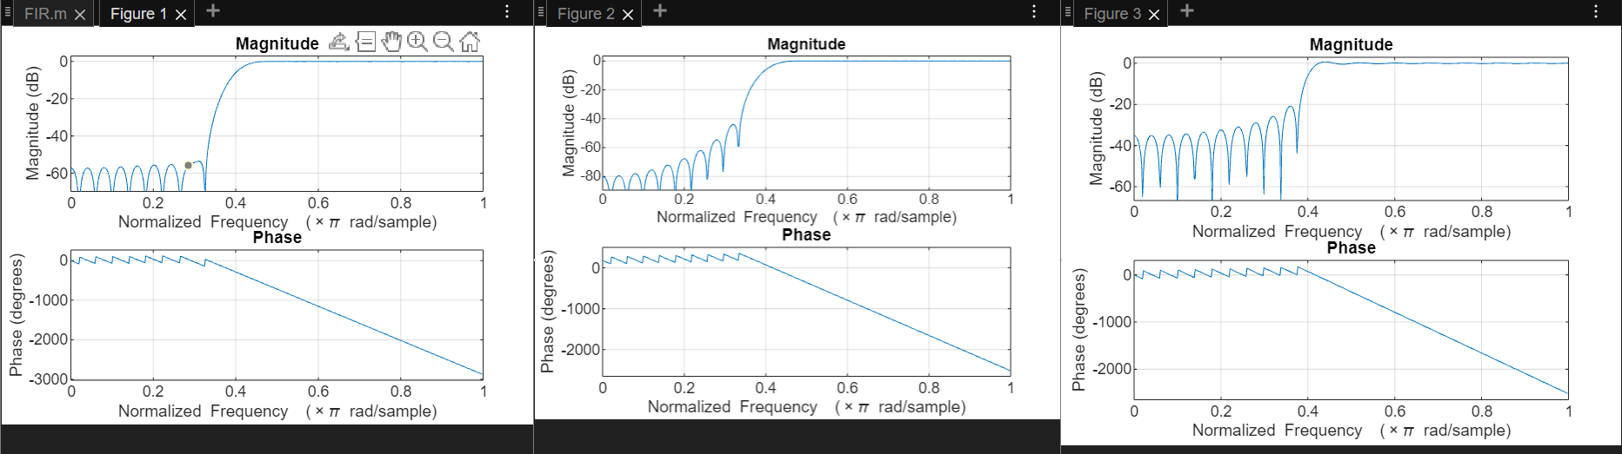

**BANDSTOP FIR FILTER:**

% Band stop

order = 48;

stopband = [0.35 0.65];

figure(1)

b = fir1(order, stopband, 'stop', hamming(order+1));

freqz(b, 1, 512);

figure(2)

b = fir1(order, stopband, 'stop', hanning(order+1));

freqz(b, 1, 512);

figure(3)

b = fir1(order, stopband, 'stop', rectwin(order+1));

freqz(b, 1, 512);

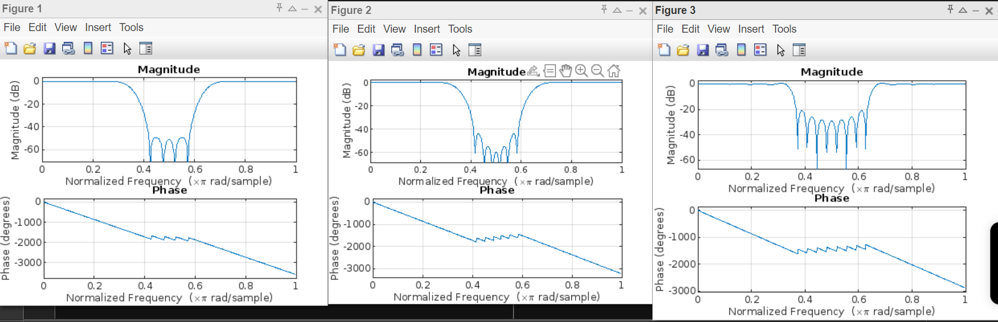

**BANDPASS FIR FILTER:**

%bandpass

order = 48;

passband = [0.2 0.5]

figure(1);

b = fir1(order, passband, 'bandpass', hamming(order+1));

freqz(b, 1, 512);

figure(2);

b = fir1(order, passband, 'bandpass', hanning(order+1));

freqz(b, 1, 512);

figure(3);

b = fir1(order, passband, 'bandpass', rectwin(order+1));

freqz(b, 1, 512);



